# *Assignment 3A –Happy Valley Kennels Use Cases*

Date assigned: Friday, September 30, 2016

Date due: **Tuesday, October 18, 2016 @ 8am (No late assignments accepted)**

**Learning Objectives**

Upon successful completion of this assignment, the student will be able to:

* Determine the roles (actors) based on given requirements.
* Determine the list of use cases based on given requirements.
* Draw a use case diagram
* Determine a glossary of terms

To do:

**Part A – Actors and Use Cases**

**Create a document called YourUserName_E11_A03_Actors_Use_Cases.docx, e.g. JSmith_E11_A03_ Actors_Use_Cases.docx, and save in the Assignment folder in the 420-E11 folder in your H drive.**

1. Create a table of the actors (roles) that exist for the Happy Valley Kennels system. Remember an actor is not a person, but a role that the person has in the system. A single person may hold many roles and the same role can be held by many persons.

|  |  |
| --- | --- |
| **Actor Name** | **Actor Description** |
| Employee | A staff member must be able to view the kennel card, view the kennel log and make reservations for clients over the phone. |
| Owner | An owner is an employee; they can do anything an employee can do. An owner can also modify prices, modify discounts and modify any available services. An owner can change the required vaccinations and modify the invoices for customers. |
| Customer | A pet owner must be able to make reservations for their pet(s) online, over the phone or in person. They must be able to fill in a contract. |

1. Create a table of the Use Cases for the HVK System. Use the case study as well as any information you picked up from your interviews. Remember these are **BUSINESS** use cases. They do **not** include specifics on HOW (database, buttons, etc) but are concerned with WHAT the system does. The use case table should have three columns: the first with the name of the use case, the second with the actors/roles that will use the use case and the third with a brief (2-4 sentences) description of the use case. Make sure that the use cases have proper names with a strong action (verb) followed by a noun (e.g. Manage Account).

|  |  |  |
| --- | --- | --- |
| **Use Case Name** | **Actors** | **Use Case Description** |
| **Employee** |  |  |
| View kennel card | Employee | Any staff member must be able to access the current kennel cards for any pet |
| View kennel log | Employee | Any staff member must be able to access the current kennel log |
| Take reservation | Employee | Any staff member must be able to make a reservation for a customer in person or over the phone |
| View customer information | Employee | A staff member must be able to view a customer’s information in order to contact them. |
| Owner |  |  |
|  | Owner | Anything an employee can do, an Owner can do |
| Modify prices | Owner | The HVK owners must be able to access the current rates for boarding or any available services and modify them |
| Modify discounts | Owner | The HVK owners must be able to access the current available discounts and modify them, get rid of them or create new available discounts |
| Modify available services | Owner | The HVK owners must be able to access the current available services and modify the services, add new services or get rid of certain ones. |
| Modify required vaccinations | Owner | The HVK owners must be able to access the current required vaccinations and add or remove vaccinations from that list. |
| Modify invoices | Owner | The HVK owners must be able to modify the current invoices for any customer to change how much they’re charging based on special circumstances |
| Customer |  |  |
| Make reservation | Customer | A customer must be able to make reservations online, over the phone or in person |
| View pet information | Customer | A customer must be able to access all of their pet’s information online. |
| Complete a contract | Customer | A customer must be able to sign a contract to get their pet into the kennel for a reservation. |

1. Use Visual Paradigm or LucidChart to create a Use Case Diagram for the Use Cases and Actors you have specified. Copy the use case diagram into the word document containing the table of actors and use cases.

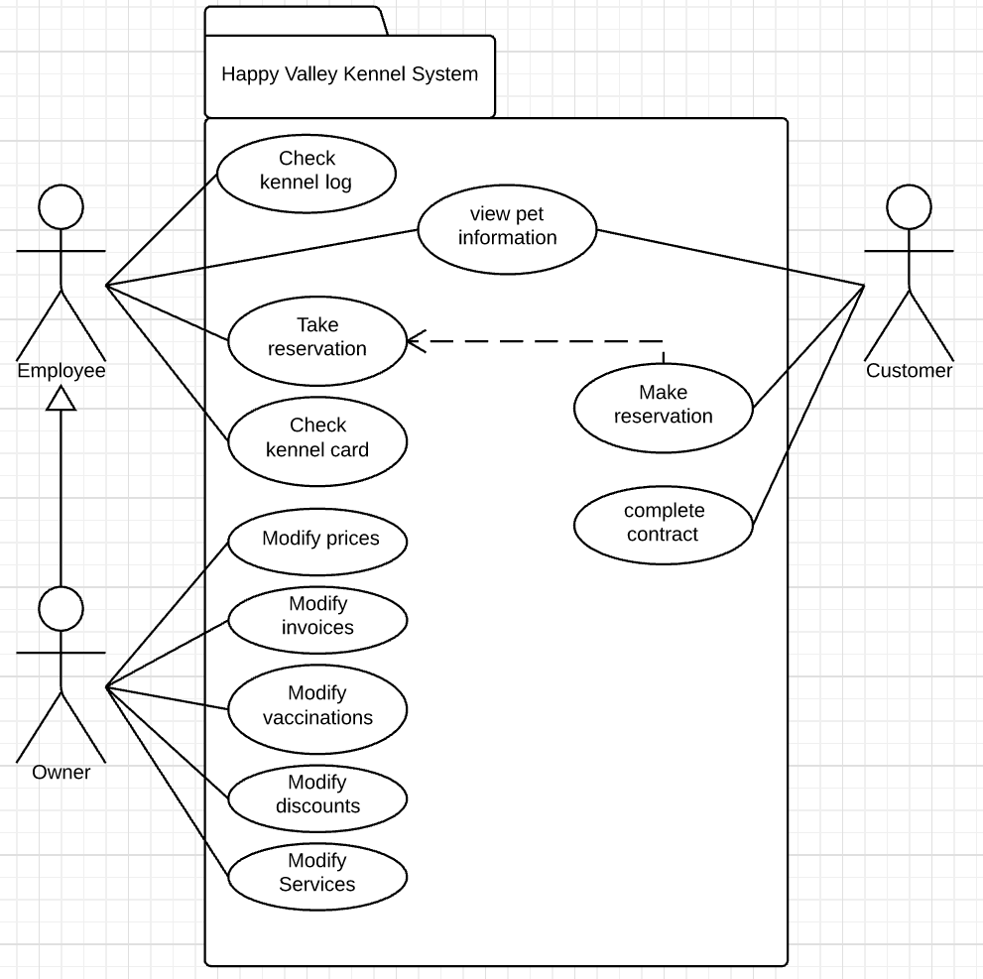

**Part B – Glossary**

**Create a document called YourUserName_E11_A03_Glossary.docx, e.g. JSmith_E11_A03_**

**Glossary.docx, and save in the Assignment folder in the 420-E11 folder in your H drive.**

Create a use case glossary or domain model for the common terms and calculations that would be used repeatedly in the Use Cases for HVK along with a brief (1 line) definition of each term. The glossary should be organized alphabetically.

**Marking Scheme**

|  |  |
| --- | --- |
|  | Marks |
| Part A – Table of Actors | 12 |
| Part A – Table of Use Cases | 15 |
| Part A – Use Case Diagram | 15 |
| Part B - Glossary | 5 |
| Organization/English | 3 |
| Total | 50 |

**To submit**

* The following Word documents must be uploaded to Moodle:
  + YourUserName_E11_A03_Actors_Use_Cases.docx
  + YourUserName_E11_A03_Glossary.docx